LEGACY BRICK PROGRAM

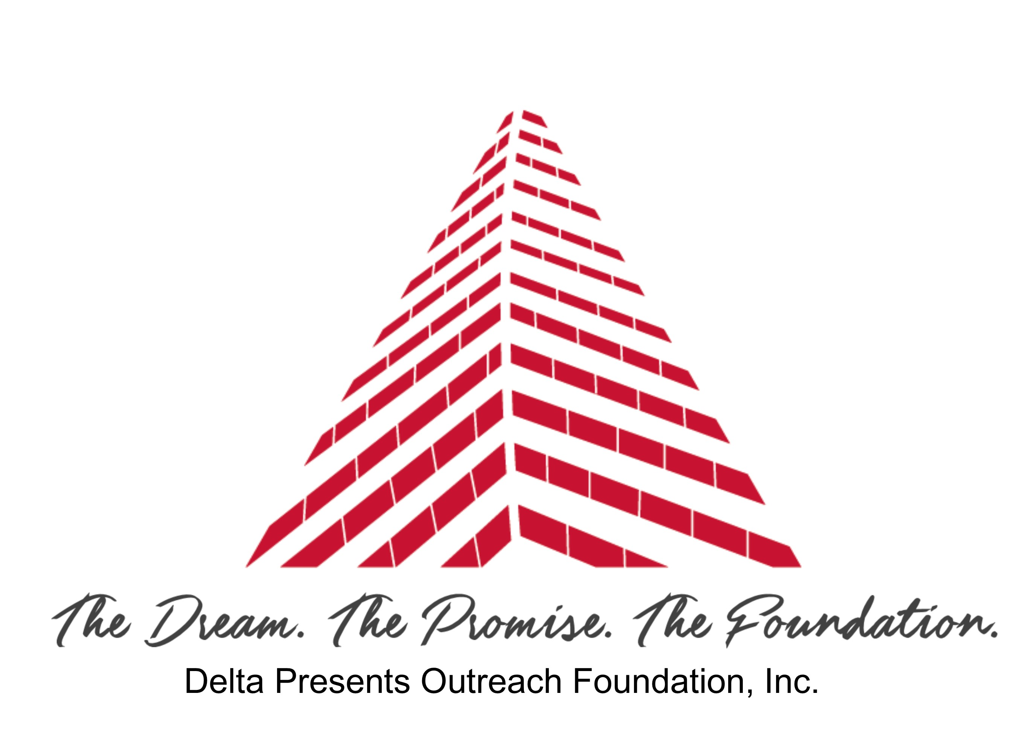

The Delta Presents Outreach Foundation, Incorporated was established in 2008. It is named after the Little Rock Alumnae Chapter’s signature program, “Delta Presents.” The Delta Presents Alumni Association was formed to commemorate the legacy of “Delta Presents,” we are raising money to support our community outreach programs and maintenance of the long-term dream of a facility designated for “public service” an accomplished fact.
4 x 8 bricks cost $100 (4 lines, 21 characters) each and 8 x 8 bricks cost $200 (6 lines, 21 characters). Engraving will be with all capital letters.
- - - - - - - - - - - - - - - - - - - - - - - - - - - - - - - - - -
Yes, I’d like to reserve a permanent “Former Honoree” brick. Please engrave my brick as follows:
ANY SYMBOL IS CONSIDERED ONE SPACE (PERIOD, COMMA, DASH)
ALL TEXT IS CENTERED
4 x 8 Brick

8 x 8 Brick

EXAMPLE
C | O | L | U | M | B | U | S |  | L |  | A | B | R | A | M | S |  | I | I | I
C | A | T | H | O | L | I | C |  | H | I | G | H |  | 1 | 9 | 9 | 1
N | B | L |  | N | E | W |  | Z | E | A | L | A | N | D
1 | 9 | 9 | 8 | ~ | 2 | 0 | 1 | 3 |  | R | E | T | I | R | E | D
M | A | T | H |  | D | E | P | A | R | T | M | E | N | T |  | C | H | A | I | R

PLEASE RETURN THIS FORM AND YOUR CHECK PAYABLE TO:
Delta Presents Alumni Association
Post Office Box 56823
Little Rock, Arkansas 72202

Name: ________________________________________ Phone: (_______) _________________________
Address: _______________________________________________________________________________
City: ____________________________________ State: ___________________ Zip: __________________
Email Address: ___________________________________________ Amount Paid: ___________________

